**Business Requirement for ??????**

Contents

1. System Overview 2

2. Requirements Scope 2

2.1 In Scope 2

2.2 Out of Scope 2

3. Functional Requirements 2

3.1 UML Use Case Diagram 2

3.1 UML Use Case Specifications 3

4. Non-Functional Requirements 5

5. Data Model 5

6. UI Screen Mockups 6

**Table of Figures**

Figure 1 - UML Use Case Diagram 3

Figure 2 - Data Model Diagram 4

Figure 3 - Cart 5

Figure 4 - Login Screen 5

*< Texts in this format are comments on how to use the template and are to be deleted when using the template>*

## System Overview

*<This section describes the system in narrative form using non-technical terms. It should provide a high-level system architecture diagram showing a subsystem breakout of the system, if applicable. >*

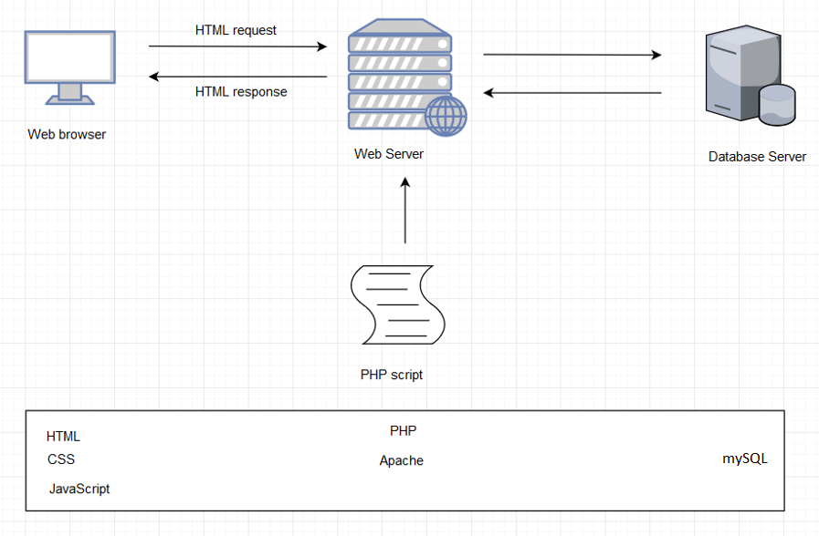

## Requirements Scope

### In Scope

* Account management
  + Customer
    - Shopping cart
    - Restaurant display
      * Rating
      * Comment
      * Image
      * Open/Close time
    - Product display and description
      * Price
      * Quantity
      * Image
      * Rating
      * Comment
    - Home page, product page, career page, about page
    - Comment and rating for each product
    - Place order, remove order, purchase order
    - Search box
    - Recommend related restaurants and products
    - Payment
    - User log in/log out
  + Restaurant
    - Receive order
    - Remove order
    - User log in/log out
  + Admin
    - Log in/Log out
    - Add restaurant
      * Add menu
    - Remove restaurant
      * Remove menu

### 2.2 Out of Scope

* Orders tracking
* Take order from text message and email
* Delivery

## Functional Requirements

*<Functional requirement are a statement of what service shall be provide to the client or user. Functional requirements required behaviors of the system. Examples: a product must be able to be added to a shopping cart; a product must be able to be deleted from the shopping cart, and so on*

*List all function requirements>*

* R01 – The client must be able to log in to an admin account
* R02 – The client must be able to add products to the web site
* R03 – Must be able to display products by categories
* R04 - Customers must register to place orders
* Must provide a fully functioning shopping cart utility where a customer can:
  + R05 – display the current items in the cart
  + R06 - add selected products to the cart
  + R07 - delete products (individually or all) from their cart
  + R08 - adjust the quantity of a selected product currently in the cart
  + R09 - preserve the contents of the cart if the user’s session is disconnected
  + R10 - have the cart accessible regardless from any machine the customer is logging in
  + R11 - provide a confirmation email sent to the client after they place their order
  + R12 - include a secure, online payment process
* R13 - Allow customers to view their order history
* R14 - Provide an intuitive, consistent look and feel to the user interface
* R15 - Use free open source software
* R16 - Have the system fully tested and up and running in 8 wee

Extra:

* R17 – Allow customers to provide reviews for any of the products they have purchased
* R18 – Must be able to display the evaluation reviews for any products
* R19 – Provide customers with appropriate product recommendations when they log in
* R20 – Provide customers with any product recommendations when they look at a particular product

### 3.1 UML Use Case Diagram

### 

### 3.2 UML Use Case Specifications

**Registration**

|  |  |  |  |
| --- | --- | --- | --- |
| **Use Case Name:** | **Customers Can Use Service After Registrations Confirmed** | **Use Case ID:** | **UC001** |
| **Primary Actor:** | **Customer** | | |
| **Description:** | **In order to use the service in our website, the customer must create an account and remain in the logged-in status in our database to interact with.** | | |
| **Triggering Event:** | **In the registration session, customers supply the personal information such as email, phone number, and address with formatting and requirements.** | | |
| **Steps Performed (Main Path)** | | | |
| 1. **Click the register button on the website** | | | |
| 1. **Fill the personal information given** | | | |
| 1. **Customers are checking the information correctly typed** | | | |
| 1. **When the customer correctly fills the information, the information filed hide, and show the next step.** | | | |
| 1. **Let the user now, the registration has been approved, and stored in the database.** | | | |
| **Extensions or Alternate Scenarios** | | | |
| 1. **Users cannot find registration button** | | | |
| 1. **Users do not fill the personal information, or not correctly put their information** | | | |
| 1. **Users don’t get confirmation email form the server** | | | |
| **Pre-Conditions:** | **The database server must connect to the registration session in the website.** | | |
| **Post-Conditions:** | **The customer must provide a correct and valid email address.** | | |
| **Assumptions:** | **Customer /restaurant is a current user/business in good standing within the system.** | | |
| **Success Guarantee:** | **1.The customer can log in successfully with the account they just have created**  **2.Users get notification email with the information about their account** | | |
| **Outstanding Issues:** |  | | |
| **Priority:** | HIGH | | |

**Check-Out**

|  |  |  |  |
| --- | --- | --- | --- |
| **Use Case Name:** | **Customers Only Can Check-Out by Credit Card Payment Method** | **Use Case ID:** | **UC002** |
| **Primary Actor:** | **Customer, Credit Card** | | |
| **Description:** | **After users are shopping, in order to get the ordering items, users have to complete check-out session with filling the credit card information** | | |
| **Triggering Event:** | **Customers entering check-out session, and credit card field shows to user to check-out the payment role.** | | |
| **Steps Performed (Main Path)** | | | |
| **1. entering check-out session after shopping** | | | |
| **2. The customers type the credit card number and extra information** | | | |
| **3.check our website receives money succesfully** | | | |
| **4. Once, the users complete their check-out, the confirmation message will be sent to customers email** | | | |
| **Extensions or Alternate Scenarios** | | | |
| **1.The customer put the wrong format of credit card** | | | |
| **2.The customer try to skip check-out session** | | | |
| **Pre-Conditions:** | 1. **The customers must be logged in** 2. **The customers must have their credit card** | | |
| **Post-Conditions:** | **The customer must get a confirmation email with a purchase receipt** | | |
| **Assumptions:** | **Customer /restaurant is a current user/business in good standing within the system.** | | |
| **Success Guarantee:** | **1.After customers paid online, the client must check the money transaction and let the users know ancomplete their check-out process.** | | |
| **Outstanding Issues:** |  | | |
| **Priority:** | HIGH | | |

**View Products**

|  |  |  |  |
| --- | --- | --- | --- |
| **Use Case Name:** | **Customer Can View Products Through Website** | **Use Case ID:** | **UC003** |
| **Primary Actor:** | **Customer** | | |
| **Description:** | **Customer can check products menu which includes product picture, product price and product rating** | | |
| **Triggering Event:** | **Customer can view products through website** | | |
| **Steps Performed (Main Path)** | | | |
| 1. **After logging in, the customer can select the different category of food to make sure which restaurant they prefer.** | | | |
| 1. **The customer views menu from selected restaurants.** | | | |
| 1. **The customer can check the picture, price and rating for each product.** | | | |
| 1. **The customer can add selected products in their cart.** | | | |
| 1. **The customer can view, add or delete current order in cart** | | | |
| **Extensions or Alternate Scenarios** | | | |
| 1. **Before the customer proceed to checkout, the downside will show some recommendation for similar dishes.** | | | |
|  | | | |
| **Pre-Conditions:** | 1. **The customer must be connected to the system** 2. **The restaurant has already registered into the system** | | |
| **Post-Conditions:** | **The customer must select at least one restaurant** | | |
| **Assumptions:** | **Customer /restaurant is a current user/business in good standing within the system.** | | |
| **Success Guarantee:** | 1. **The customer can check product picture, product price and product rating clearly after selected a restaurant.** 2. **The customer can check current recommendation for restaurant and dishes in main page** 3. **The customer can view/change the current order in their cart** | | |
| **Outstanding Issues:** |  | | |
| **Priority:** | LOW | | |

**Log In**

|  |  |  |  |
| --- | --- | --- | --- |
| **Use Case Name:** | Logging in for Customer, Admin and Restaurant | **Use Case ID:** | **UC004** |
| **Primary Actor:** | **Customer, Admin, Restaurant** | | |
| **Description:** | **Customer, admin and restaurant can log in the system after they registered.** | | |
| **Triggering Event:** | **Customer, admin and restaurant can log in the system after they registered.** | | |
| **Steps Performed (Main Path)** | | | |
| 1. **Customer or Admin or restaurant owner open the system.** | | | |
| 1. **After they registered, they can access the system through log in page** | | | |
| 1. **After logged in, customer or admin or restaurant owner can enter different main page.** | | | |
| **Extensions or Alternate Scenarios** | | | |
| 1. **After customer log in, the website should base on the current main page with the recommendation options.** | | | |
| 1. **After admin log in, they can manage the customer’s and restaurant’s message** | | | |
| 1. **After restaurant log in, they can manage the order details from customers through the system** | | | |
| **Pre-Conditions:** | 1. **The customer must log in and active** 2. **The admin must log in.** 3. **The restaurant must log in** | | |
| **Post-Conditions:** | **Restaurants, admins and customers must already registered into the system.** | | |
| **Assumptions:** | **Customer /restaurant is a current user/business in good standing within the system.** | | |
| **Success Guarantee:** | 1. **The customer can log in and active successfully.** 2. **The admin can log in and active successfully.** 3. **The restaurant can log in and active successfully.** | | |
| **Outstanding Issues:** |  | | |
| **Priority:** | HIGH | | |

|  |  |  |  |
| --- | --- | --- | --- |
| **Use Case Name:** | **Add restaurant** | **Use Case ID:** | **UC05** |
| **Primary Actor:** | **Admin** | | |
| **Description:** | **Admin can add more restaurant to the website** | | |
| **Triggering Event:** | **Add restaurant button** | | |
| **Steps Performed (Main Path)** | | | |
| 1. **Admin login to the site** | | | |
| 1. **Admin choose add restaurant button** | | | |
| **Extensions or Alternate Scenarios** | | | |
| 1. **Admin can cancel adding process. Go back to home screen** | | | |
| 1. **Admin will add restaurant’s information, contact, location, menu, price, etc…** | | | |
| 1. **After all alert a confirmation message** | | | |
|  | | | |
| **Pre-Conditions:** | 1. **Admin must be connected to the website** 2. **Admin must chose add restaurant option** | | |
| **Post-Conditions:** | **Admin must fill all information for that restaurant or added at least one restaurant** | | |
| **Assumptions:** | **Admin knows how to use and manage the site** | | |
| **Success Guarantee:** | **Admin added a restaurant successfully** | | |
| **Outstanding Issues:** | **Admin cannot add restaurant**  **Admin added a restaurant without important informations** | | |
| **Priority:** | **High** | | |

|  |  |  |  |
| --- | --- | --- | --- |
| **Use Case Name:** | **Remove restaurant** | **Use Case ID:** | **UC06** |
| **Primary Actor:** | **Admin** | | |
| **Description:** | **Admin can remove restaurant on the website** | | |
| **Triggering Event:** | **Remove restaurant button** | | |
| **Steps Performed (Main Path)** | | | |
| 1. **Admin login to the site** | | | |
| 1. **Admin choose remove restaurant button** | | | |
| **Extensions or Alternate Scenarios** | | | |
| 1. **Admin can cancel removing process. Go back to home screen** | | | |
| 1. **Admin will choose which restaurant he/she wants to be removed then click delete button.** | | | |
| 1. **Alert a confirmation message when delete button is clicked** | | | |
|  | | | |
| **Pre-Conditions:** | 1. **Admin must be connected to the website** 2. **Admin must chose remove restaurant option** | | |
| **Post-Conditions:** | **Admin must choose at least one restaurant to be removed** | | |
| **Assumptions:** | **Admin knows how to use and manage the site** | | |
| **Success Guarantee:** | **Admin removed a restaurant successfully** | | |
| **Outstanding Issues:** | **Admin cannot remove restaurant**  **The restaurant’s information not deleted properly**  **Every restaurant is deleted** | | |
| **Priority:** | **High** | | |

|  |  |  |  |
| --- | --- | --- | --- |
| **Use Case Name:** | Receive and View Orders | **Use Case ID:** | **UC007** |
| **Primary Actor:** | Restaurant users | | |
| **Description:** | The customer’s orders are sent to the restaurant view. The restaurant can view the orders they receive and cook it | | |
| **Triggering Event:** | When the customer made purchases | | |
| **Steps Performed (Main Path)** | | | |
|  | | | |
| 1. The restaurant is logged In | | | |
| 1. There’s someone made an order at their own category menu in the website | | | |
| 1. The confirmation of the order | | | |
| 1. The system will sent the order to the restaurant view | | | |
| **Extensions or Alternate Scenarios** | | | |
| 2.a The customers canceled their order | | | |
|  | | | |
|  | | | |
|  | | | |
| **Pre-Conditions:** | The restaurant must be register in the database, after that they just need to log in. | | |
| **Post-Conditions:** | The restaurant has cooked the order they receive. | | |
| **Assumptions:** | The Restaurant receive the orders | | |
| **Success Guarantee:** | The restaurant’s cook will cook the order they receive | | |
| **Outstanding Issues:** | 1. **Does the system know if the restaurant’s menu is out of stock?** | | |
| **Priority:** | High | | |

|  |  |  |  |
| --- | --- | --- | --- |
| **Use Case Name:** | Remove orders | **Use Case ID:** | **UC008** |
| **Primary Actor:** | Restaurant users | | |
| **Description:** | The restaurant can remove the orders they recieved | | |
| **Triggering Event:** | When the resstaurant wants to remove the order | | |
| **Steps Performed (Main Path)** | | | |
|  | | | |
| 1. The restaurant must be log in | | | |
| 1. The Restaurant must have received the ordes | | | |
| 1. The resraurant select what orders they want to remove | | | |
|  | | | |
| **Extensions or Alternate Scenarios** | | | |
|  | | | |
|  | | | |
|  | | | |
|  | | | |
| **Pre-Conditions:** | The restaurant must be log in to the database, they also must have received the orders | | |
| **Post-Conditions:** | The restaurant erased the orders | | |
| **Assumptions:** | Restaurant’s menu run out of stock | | |
| **Success Guarantee:** | The restaurant has delete the orders they recieve | | |
| **Outstanding Issues:** | 1. **Does the system will recommend the other menu equivalent to the food they order?** | | |
| **Priority:** | Medium | | |

## Non-Functional Requirements

*<Non-Functional Requirements – characteristics the software must possess such as reliability, portability, security, maintainability, usability, learnability and availability .This is usually to do with implementation details, performance requirements, and/or environment. Examples: the system will use the nginx web server.>*

* Performance: Each page responses time 3 sections
* Security: The password for accounts should be encrypted in one way direction.

## Data Model

*<Include your Entity Relation diagram that you create in MySQL Workbench here.*

*For Example:*

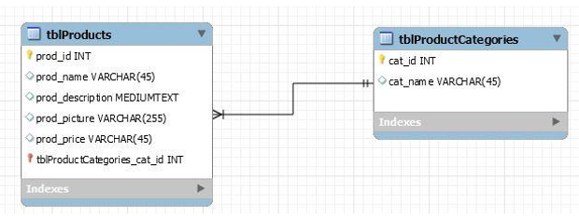

Figure 2 - Data Model Diagram

*>*

## UI Screen Mockups

*<Include your any screen mock-ups here for the web site, indicate which use case they are for*

*For Example*

*6.1 The following screen is for UC001 and shows the current contents of the shopping cart.*

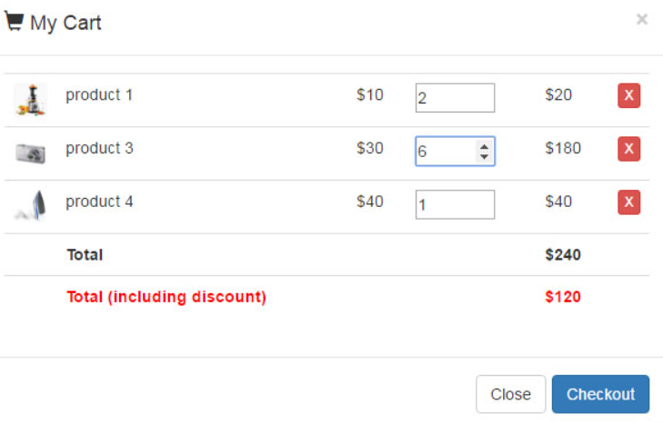

Figure 3 - Cart

*6.2 The following screen is the for use case UC002 and shows the login screen.*

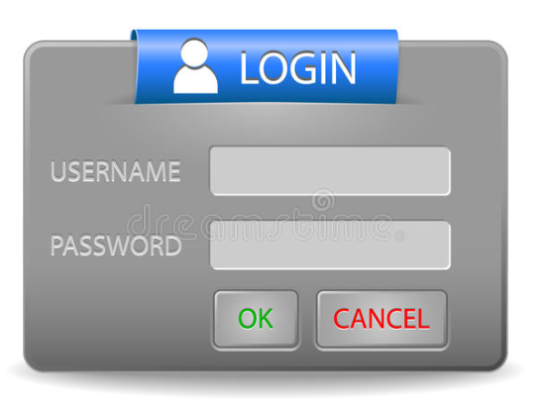

Figure 4 - Login Screen